The source is the United States Geological Survey (USGS) Nonindigenous Aquatic Species (NAS) data set. It is a collection of zebrafish sightings across the United States. Included is a point map that represents the number of individuals by the color and size of the circle superimposed on a map of the United States. Also included is an Excel spreadsheet including species identification, latitude and longitude, phase of establishment, and date of sighting, among other information.

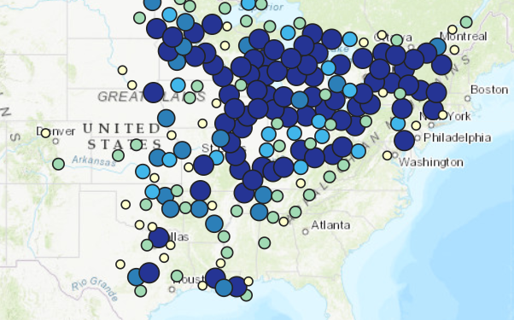

**Figure 1**

**Zebra fish sightings represented by size and color of circle – darker and larger circle correspond to a greater number of individuals. Source: USGS NAS**

The map includes Hydraulic Unit Codes (HUC), a system derived by USGS to delimit subregions within the country.

An inquiry then could be to standardize each HUC by area to find the number of zebra mussels per unit area to determine at which locations the highest density occurs. Similarly, bins of degrees of latitude could be derived (to reduce the step of standardization and bypass the use of HUC altogether, a possible benefit of which would be that measurements of latitude might yield more climatically relevant data rather than political/economic divisions), to again determine the density of zebra mussels per unit (as yet to be defined). This could be combined with climatic information to determine which climate conditions favor the establishment and invasion of zebra mussels to the most severe extent.